|  |  |  |
| --- | --- | --- |
| Best Place to Live Seattle vs San Francisco | | |
|  |  |  |
| Author: Juan Vargas | | |

# Contents

**Introduction**

* Background of the problem
* Problem specification
* Recommended Audience

**Data**

* Data required
* How the data will be collected
* How the data will solve the problem

**Methodology**

* Steps and processes to solve the problem
* Tools and methods employed to solve the problem
* How the data will be collected

**Results**

* Presentation of the results

**Conclusion**

* How the analysis will help to take a better decision

# Introduction

#### **Background**

Since the tech boom in the 90's in the USA with the internet going mainstream, rent prices have grown almost exponentially in cities were disruptive tech is develop every day. Now home towns for the big four made Amazon, Facebook, Google, and Apple, made very big changes in their respective cities, disrupting the real state markets with their presence in this cities, as the economies and the way of living on these tech hub communities.

There are a lot of costs that need to be considered if one plans to live in these cities, having a job in tech pays good money but you won’t be able to keep more than 40% of your salary, so decision must be taken an all the options to improve your quality of living must be explored.

#### **Problem Specification**

Two of the must work to cities for developers, data scientists and any high performance professional in general in 2020 are San Francisco California and Seattle Washington in the USA. It does not really matter where you come from if you have the skills and make the commitment there is a 'back breaking' job waiting for you there, tech jobs pay handsomely but rent prices specially in the bay area (San Francisco) are not cheap. Paying rent in the USA is one of the major expenses that a professional have. With this project I try to convey the rent expense on different neighborhoods of both tech hub cities so you may choose the neighborhood that makes sense to you financially speaking, also recreational venues information is display just in case money is not an issue but life style is.

#### **Recommended audience**

This project looks to help the potential resident, anybody looking to work in the USA in the tech industry in general, this report might be a great starting point to consider the different factors of relocating to a US tech city.

# data

The goal of the project is basically to compare venues and rent prices of two of the major cities for tech workers in the west coast of the USA the data required for that purpose and the tools are the following:

#### **Data required**

* Utilizing geopy along the proper coordinates of the cities I'll create the data frames need it for making visual maps of the neighborhoods.
* With the help of Foursquare I'll gather a table of the best venues that the neighborhoods in the two cities are process appropriately.
* Utilizing geopy along the proper coordinates of the cities I'll create the data frames need it for making visual maps of the neighborhoods.
* Since the rent price information will be scraped on different websites cited on sources at the end of the project, the number of neighborhoods must match both cities for statistical comparison.

#### **How the data collected will solve the problem and what questions does it answer?**

* What is the best value of rent in neighborhoods of both cities?
* Which neighborhood of each city has the most venues?
* Which neighborhood of each city has the vest venues?
* The data collected and processed will let the investor (reader) make the best choice of picking the right city for him or her.
* The visuals will let the investor (reader) see on a map the relative closeness to a future working address.

#### **Collecting the Data**

Data scraping from websites cited on the references at the end of this report was collected and converted into data frames with help of the library pandas using the programming language python, additionally coordinates information was acquired with the help of Nominatim and geocode, at first I tried geocoder with no success so I decided to switch libraries, simultaneously the coordinates information was added to the data frames for each city.

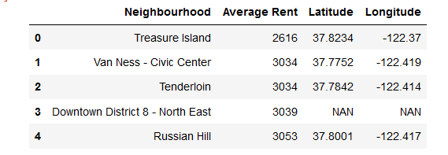

**Fig 1. San Francisco Neighborhoods with rent prices and coordinates information.**

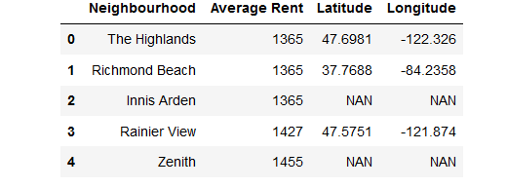

**Fig 2. Seattle Neighborhoods with rent prices and coordinates information.**

After that the data was cleaned and the sizes of the data frames for both cities were match, some of the coordinates information was missing as is shown in the figure 1 and figure 2 above.

# Methodology

Once the relevant information has been gathered it is time to start conducting the relevant statistical analysis to obtain the desired results.

Data has been collected scraping websites with the necessary information, some data cleaning has been performed and some reshaping still remains to be performed in order to compare rent prices in both cities, statistical methods will be employed in order to achieve this purpose, the tools used so far are the following:

* Pandas
* Numpy
* Geopy
* Nominatim
* Geocode
* Folium

More of the steps to solve the problem involve the use of Machine Learning in order to classify the venues of both the cities into clusters and obtain a very good picture of what is the best choice for the working professional, this tools will be used for that purpose:

* Sklearn
* Kmeans
* FourSquare
* Kmeans
* Matplotlib
* Seaborne

### ***Methodology Steps implementation***

All the data must be classified appropriately and the results must answer all the questions stated at the begging of this document. The problem that I'm looking to solve is to give the best possible house renting choice for the individual looking to work in one of the two tech center cities in the USA.

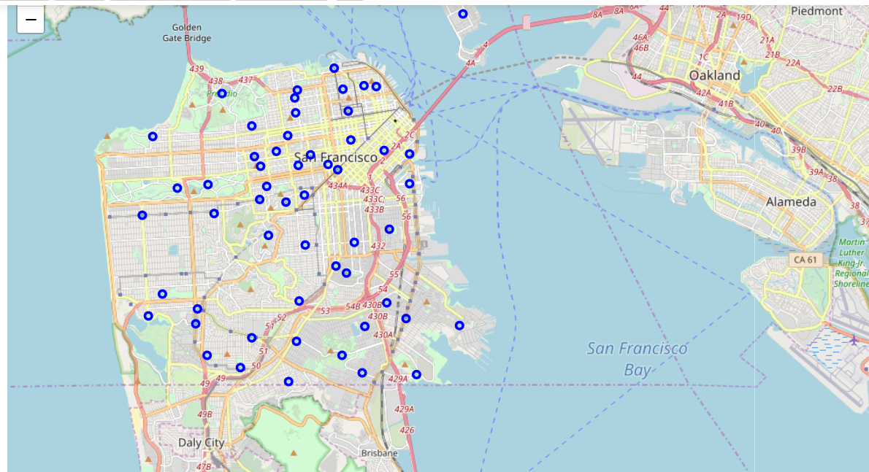

**Fig 3. Map of San Francisco’s Neighborhoods.**

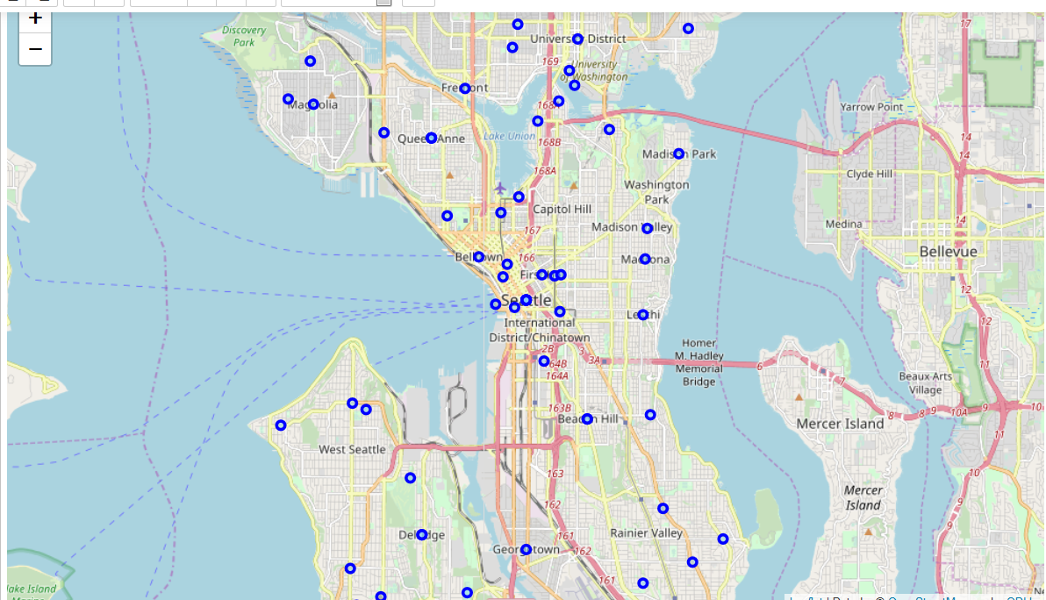

**Fig 4. Map of Seattle’s Neighborhoods.**

# Results

The research and analysis applied for this project returned the following infomation regarding the tech cities compared.

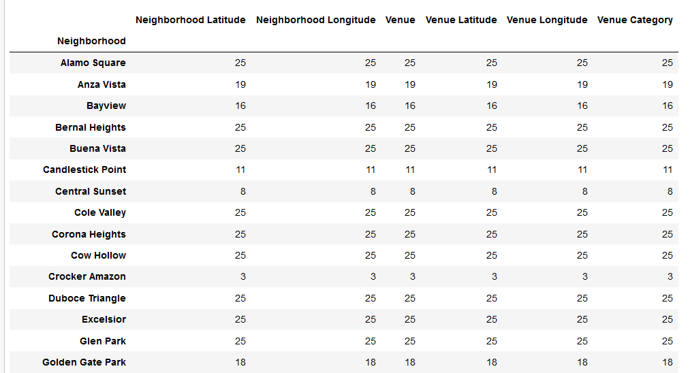

**Fig 5. Data Frame of San Francisco venues in each neighborhood.**

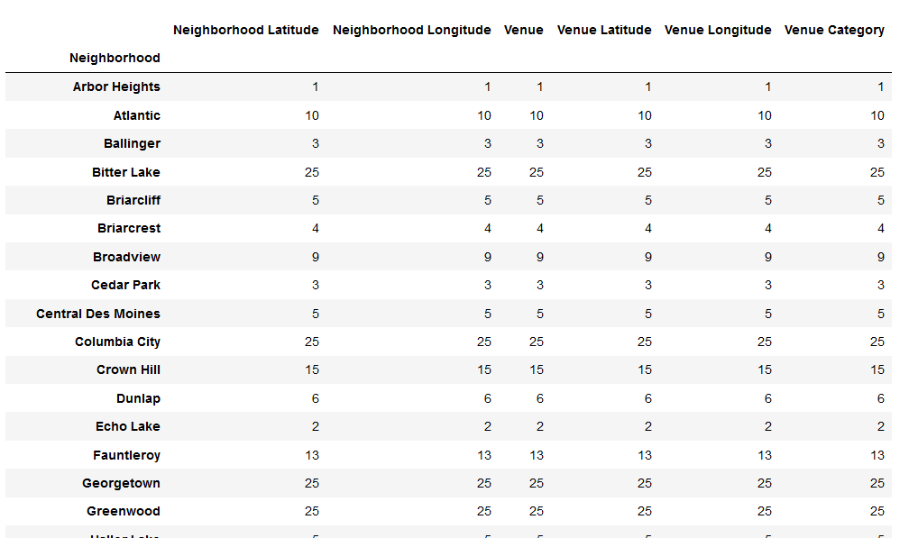

**Fig 6. Data Frame of Seattle venues in each neighborhood.**

It is clear based on the analysis that San Francisco has the bigger number of venues per neighborhood(Figures 5 and 6), and from the maps (Figures 3 and 4) we can determine that San Francisco’s population is more dense than Seattle’s the is a greater concentration of neighbor hoods in San Francisco.

Finally the statistical comparison of these two cities will give us the following information:

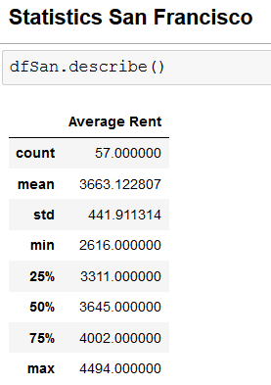 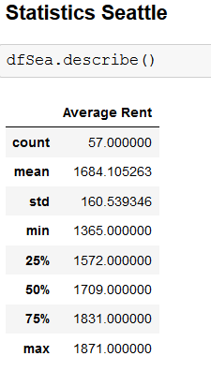

**Fig 7. Statistical comparison between San Francisco and Seattle.**

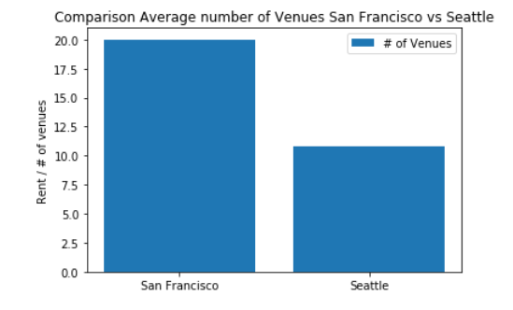

**Fig 8. Comparison of number of venues in San Francisco and in Seattle.**

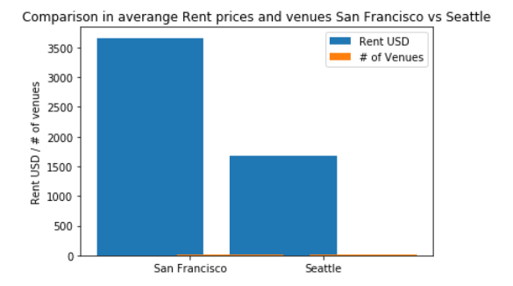

**Fig 9. Comparison Rent in USD and number of venues in San Francisco and in Seattle.**

The results are pretty clear living in any of those two cities and in the USA in general is not cheap, the minimum average rent for Seattle is $1375 USD and $2616 USD for San Francisco, and let’s considers that this keeps going up.

# conclusion

If it is in your plans work in the USA in any of the major tech cities like San Francisco or Seattle you should really consider not only the salary that you will earn there, but also the cost of living should be a really big factor in your decision, and lets not even mention the hours and fast pace style of living that you might not be used to.

The Graphs of comparison of the two cities show us that there is a huge difference in average rent prices when it comes to the location of work, San Francisco in the bay area being the city with the major players in tech worldwide to date, is the most expensive city to live in, living costs are inflated there, average rent prices are $3600 USD just the rent, remember there is also the transportation and eating costs not taken into account in this report's analysis.

There are at least two venues in San Francisco per venue in Seattle. A lot to do in San Francisco provided you can find the time once you are there. On the other hand Seattle rent prices are $1700 USD on Average, if you don't mind the rainy weather and almost half the venues than in San Francisco, Seattle should be definitely be you destiny.

Also I think that is important to mention that rent prices keep going up in those cities as they keep attracting the best brains in the world and the huge amount of money injected there from investors worldwide keeps real state and cost of living sky high.

I hope that with this work at least I've shown you a different perspective of what working and probably living in tech cities implies.

# references

[1] "[https://www.businessinsider.com/san-francisco-housing-so-expensive-people-leaving-2018-4/?r=MX&IR=T"](https://www.businessinsider.com/san-francisco-housing-so-expensive-people-leaving-2018-4/?r=MX&IR=T%22)

[2] "[https://matplotlib.org/"](https://matplotlib.org/%22)

[3] "[https://www.rentcafe.com/average-rent-market-trends/us/ca/san-francisco/"](https://www.rentcafe.com/average-rent-market-trends/us/ca/san-francisco/%22)

[4] "[https://www.rentcafe.com/average-rent-market-trends/us/wa/seattle/"](https://www.rentcafe.com/average-rent-market-trends/us/wa/seattle/%22)

[5] "[https://towardsdatascience.com/geocode-with-python-161ec1e62b89"](https://towardsdatascience.com/geocode-with-python-161ec1e62b89%22)

**THANK YOU!**